COS10007 Developing Technical Software TP 1 2023

Assignment 1 report

Name: Son Nguyen, Student ID:103234103

Lab class: Wednesday 2:30 Teacher: Nalin Randeniya

Due Date: Tuesday 4th of April 2023 at 11:59 PM

Date Submitted: Tuesday 4th of April 2023 at 8:39PM

Question 1

Program description
Program is design to take in 5 characters from your last name then create and display the linked List. It’s also responsible for sorting the input letters into alphabetical order before printing the final List onto the screen. It’s just a program that is meant to solve linking pointer with each other and which take priority before outputting the 5 characters for the last name.

Inputs and Outputs
The inputs and outputs for this program are described in Table 1.

Table 1. Data dictionary:
Data to be stored | Sample data | Type of data | C type | Input method | In /  Out | Variable name
first letter | N | Text:1 letter | char  pointer | Input | printf | letter
Second letter | G | Text:1 letter | char  pointer | Input | Printf | letter
Third letter | U | Text: 1 letter | Char  pointer | Input | Printf | letter
Fourth letter | Y | Text:1 letter | Char  pointer | Input | Printf | Letter
Fifth Letter | E | Text:1 letter | Char  Pointer | Input | Printf | Letter

3. Algorithm
Program steps:
- Define structure.
- Define node name.
- Initialize pointer.
- Input data into pointer
- Repeat step 4 until all the satisfied data are input.
- Re-arrange the pointer into alphabetical format when asked.
- Ready to input into a displayList
- Print the displayList onto screen with all pointers assigned

Source code:
//Son Nguyen - 103234103
// Assignment 1 - COS10007//
// Question 1//
#include <stdio.h>
#include <stdlib.h>

struct studentname {
char letter;
struct studentname *next;
};
typedef struct studentname STUDENTName;
typedef STUDENTName *STUDENTNamePtr;

void displayList(STUDENTNamePtr currentPtr);

int main() {
// Initialize pointer
STUDENTNamePtr startPtr = NULL;

// 1st letter of last name N
STUDENTNamePtr newPtr = (STUDENTNamePtr) malloc(sizeof(STUDENTName));
newPtr->letter = 'N';
newPtr->next = NULL;
startPtr = newPtr;

// 2nd letter of last name G
newPtr = (STUDENTNamePtr) malloc(sizeof(STUDENTName));
newPtr->letter = 'G';
newPtr->next = NULL;
if (newPtr->letter < startPtr->letter) {
newPtr->next = startPtr;
startPtr = newPtr;
} else {
startPtr->next = newPtr;
}

// 3rd letter of last name U
newPtr = (STUDENTNamePtr) malloc(sizeof(STUDENTName));
newPtr->letter = 'U';
newPtr->next = NULL;
if (newPtr->letter < startPtr->letter) {
newPtr->next = startPtr;
startPtr = newPtr;
} else {
STUDENTNamePtr prevPtr = startPtr;
STUDENTNamePtr currentPtr = startPtr->next;
while (currentPtr != NULL && newPtr->letter > currentPtr->letter) {
prevPtr = currentPtr;
currentPtr = currentPtr->next;
}
prevPtr->next = newPtr;
newPtr->next = currentPtr;
}

// 4th letter of last name Y
newPtr = (STUDENTNamePtr) malloc(sizeof(STUDENTName));
newPtr->letter = 'Y';
newPtr->next = NULL;
if (newPtr->letter < startPtr->letter) {
newPtr->next = startPtr;
startPtr = newPtr;
} else {
STUDENTNamePtr prevPtr = startPtr;
STUDENTNamePtr currentPtr = startPtr->next;
while (currentPtr != NULL && newPtr->letter > currentPtr->letter) {
prevPtr = currentPtr;
currentPtr = currentPtr->next;
}
prevPtr->next = newPtr;
newPtr->next = currentPtr;
}
// 5th letter of last name E
newPtr = (STUDENTNamePtr) malloc(sizeof(STUDENTName));
newPtr->letter = 'E';
newPtr->next = NULL;
if (newPtr->letter < startPtr->letter) {
newPtr->next = startPtr;
startPtr = newPtr;
} else {
STUDENTNamePtr prevPtr = startPtr;
STUDENTNamePtr currentPtr = startPtr->next;
while (currentPtr != NULL && newPtr->letter > currentPtr->letter) {
prevPtr = currentPtr;
currentPtr = currentPtr->next;
}
prevPtr->next = newPtr;
newPtr->next = currentPtr;
}

// Print the list
displayList(startPtr);

// Free the memory
while (startPtr != NULL) {
STUDENTNamePtr tempPtr = startPtr;
startPtr = startPtr->next;
free(tempPtr);
}

return 0;
}

void displayList(STUDENTNamePtr currentPtr)
{
printf("Last Name\n");
while (currentPtr != NULL) {
printf("%c\n ", currentPtr->letter);
currentPtr=currentPtr->next;
}
}

Screenshots showing working program (Show all possible outcome):
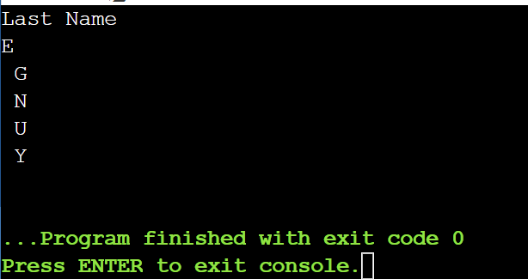

Question 2

Program description

Program design to print a menu given 6 options – to see current employee list , to search for an employee’s salary , find largest/average/and for employee receiving under 5000, there is also an option to add an additional person to the record. Using pointer/node and such to create the menu. Also a button to quit program

Inputs and Outputs
The inputs and outputs for this program are described in Table 1.

Table 1. Data dictionary:
Data to be stored | Sample data | Type of data | C type | Input method | In /  Out | Variable name
Txt file | Employee | Text: at least 10 employees | C | Fscanf | Fprintf | Employee.txt

3. Algorithm
Program steps:
- File is read, structure is initialized.
- Menu is printed.
- Scan the input – if its number relevant on screen, program will continue like below otherwise will print necessary error.
- If option 1 is pick, print out all employee’s detail.
- If option 2 is pick, a command will show up where it will ask you to find the name of the employee you want to search for , if found it’ll print out the details of anyone in text file. If not , will print a response then return to menu
- If option 3 is pick , menu will search through the .txt file for employee with the highest salary and return to main()
- If option 4 is pick, program will run a search for employee > 5000 and print out the result and then return to menu.
- If option 5 is pick, menu will ask for input via what company you are searching for. If fit with a company in txt -> program would proceed to print average of employee, if no company – program will print error message. Both options will return you to original menu
- If option 6 is pick , a set of questions will be ask in order to add an additional name to the system. Name/Age/ID/CompanyName/Salary to be added.
- If option 7 is pick, it’ll terminate the program after displaying an appropriate message.

Source code:

//Son Nguyen - 103234103//
//COS10007 - Assignment 1//
// Question 2//
#include <stdio.h>
#include <stdlib.h>
#include <string.h>
//structure
struct personTag{
char name[20];
int age;
};

struct officialTag{
int deptId;
char cmpName[20];
double salary;
};

struct employeeTag{
struct personTag personalInfo;
struct officialTag officialInfo;
struct employeeTag *next;
};

struct Node{
struct employeeTag data;
struct Node *next;
};
//reading file from employee.txt
void readFile(struct Node** headNode){
FILE * fptr;
if ((fptr = fopen("employee.txt", "r")) == NULL){
printf("file does not exist. Exiting the program.");
exit(1);
}

char firstLine[100];
fgets(firstLine, 100, fptr);

struct Node* node = NULL;
node = (struct Node*)malloc(sizeof(struct Node));
//scanning all the data into respective node
while(fscanf(fptr, "%s %d %d %s %lf", node->data.personalInfo.name, &node->data.personalInfo.age, &node->data.officialInfo.deptId, node->data.officialInfo.cmpName, &node->data.officialInfo.salary) == 5){
struct Node* prev = NULL;
struct Node* cur = *headNode;

while(cur != NULL && strcmp(cur->data.personalInfo.name, node->data.personalInfo.name) < 0){
prev = cur;
cur = cur->next;
}

if(prev == NULL){
node->next = *headNode;
*headNode = node;
}
else{
prev->next = node;
node->next = cur;
}
node = (struct Node*)malloc(sizeof(struct Node));
}
fclose(fptr);
}
//displaying Employee information
void displayEmployees(struct Node* node){
printf("Employee Information:\nName\t\tAge\t\tID\t\tCompany\t\tSalary\n");
while (node != NULL){
printf("%s\t\t%d\t\t%d\t\t%s\t\t%.2f\n", node->data.personalInfo.name, node->data.personalInfo.age, node->data.officialInfo.deptId, node->data.officialInfo.cmpName, node->data.officialInfo.salary);
node = node->next;
}

}
// Menu Interface
int Menu(){
printf("\n\nPlease select one of the following menu options:\n");
printf("(1) Display employee's details\n"
"(2) Search for an employee's salary\n"
"(3) Find the details of employee with the largest salary\n"
"(4) Find the details of all employees having salary less than 5000\n"
"(5) Find the average salary of a company\n"
"(6) Add new employee to the record\n"
"(7) Quit program\n");
int option;
int errorChecking;
errorChecking = scanf("%d", &option);
// checking for input
while(errorChecking != 1){
printf("invalid input. Please enter a number\n");
while (getchar() != '\n'){}
errorChecking = scanf("%d", &option);
}
return option;
}
// Search for Employee
void searchEmployee(struct Node* node, char *name){
int Found = 0;
while (node != NULL){
if (strcmp(node->data.personalInfo.name, name) == 0){
if (Found == 0){
printf("\nName\t\tAge\t\tID\t\tCompany\t\tSalary\n");
}
printf("%s\t\t%d\t\t%d\t\t%s\t\t%.2f\n", node->data.personalInfo.name, node->data.personalInfo.age, node->data.officialInfo.deptId, node->data.officialInfo.cmpName, node->data.officialInfo.salary);
Found = 1;
}
node = node->next;
}
if (Found == 0){
printf("Employee not found\n");
}
}
// Finding maximum salary
void findMaximum(struct Node* node){
int maxSal = 0;
struct Node* maxSalNode = (struct Node*)malloc(sizeof(struct Node));
while (node != NULL){
if (node->data.officialInfo.salary > maxSal){
maxSal = node->data.officialInfo.salary;
maxSalNode = node;
}
node = node->next;
}
node = maxSalNode;
printf("\nName\t\tAge\t\tID\t\tCompany\t\tSalary\n");
printf("%s\t\t%d\t\t%d\t\t%s\t\t%.2f\n", node->data.personalInfo.name, node->data.personalInfo.age, node->data.officialInfo.deptId, node->data.officialInfo.cmpName, node->data.officialInfo.salary);
}
//Finding salary of employees less than 5000
void lowerSalary(struct Node* node){
printf("Details of all employees with salary less than 5000 are listed below:\n");
printf("Name\t\tAge\t\tID\t\tCompany\t\tSalary\n");
while (node != NULL){
if (node->data.officialInfo.salary < 5000){
printf("%s\t\t%d\t\t%d\t\t%s\t\t%.2f\n", node->data.personalInfo.name, node->data.personalInfo.age, node->data.officialInfo.deptId, node->data.officialInfo.cmpName, node->data.officialInfo.salary);
}
node = node->next;
}
}
//Finding average salary
void averageSalary(struct Node* node, char* compN){
double total = 0.0;
int count = 0;
while (node != NULL){
if (strcmp(node->data.officialInfo.cmpName,compN) == 0){
count += 1;
total += node->data.officialInfo.salary;
}
node = node->next;
}
if (count == 0){
printf("Company not found in the database\n");
}
else{
printf("The average salary of all employees of %s is %.2f", compN, total/count);
}
}
//Update File with new Employees
void updateFile(){
FILE *fptr;
char name[20], cmpName[20];
int age, deptId;
double salary;

if ((fptr = fopen("employee.txt", "a")) == NULL){
printf("file does not exist. Exiting the program.");
exit(1);
}
printf("Enter the name of the employee: ");
scanf("%s", name);
printf("Enter the age of the employee: ");
scanf("%d", &age);
printf("Enter the department ID of the employee: ");
scanf("%d", &deptId);
printf("Enter the name of the company the employee works at: ");
scanf("%s", cmpName);
printf("Enter the salary of the employee: ");
scanf("%lf", &salary);
fprintf(fptr, "%s %d %d %s %.2f\n", name, age, deptId, cmpName, salary);
fclose(fptr);
}
// freeing memory
void emptyList(struct Node** node){
struct Node* cur = *node;
struct Node* nex;
while (cur != NULL){
nex = cur->next;
free(cur);
cur = nex;
}
*node = NULL;
}
//Starting the option menu
int main(){
printf("Assignment 1 - Question 2 Menu\n");
struct Node* head = NULL;
readFile(&head);
int op = Menu();
while (op != 7){
switch(op){
case 1: //case 1 - display employee
displayEmployees(head);
break;
case 2://case 2 - search employee
printf("Input the name of the employee you wish to find:\n");
char Name[20];
scanf("%s", Name);
searchEmployee(head, Name);
break;
case 3://case 3 - find Maximum
findMaximum(head);
break;
case 4://case 4 - find lower than 5k
lowerSalary(head);
break;
case 5: //case 5 - average salary
printf("Input the name of the company you wish to look up:\n");
char companyName[20];
scanf("%s", companyName);
averageSalary(head, companyName);
break;
case 6: // case 6 - update
updateFile();
emptyList(&head);
readFile(&head);
displayEmployees(head);
break;
default:
printf("Incorrect option, try again\n");
break;
}
op = Menu();
printf("\n");
}
printf("Thank you for using my code - Son Nguyen!\n");
return 0;
}

Screenshots showing working program (Show all possible outcome):
Start of the program
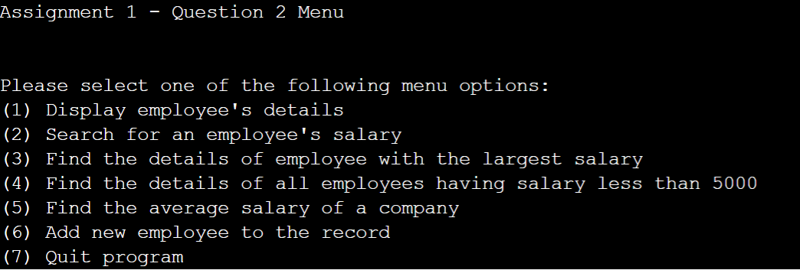
Option 2
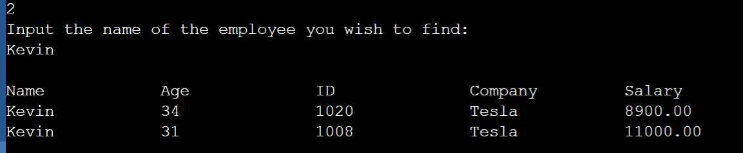
Option 3
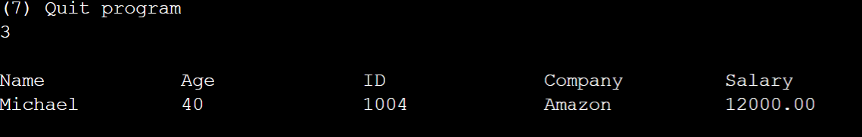
Option 4

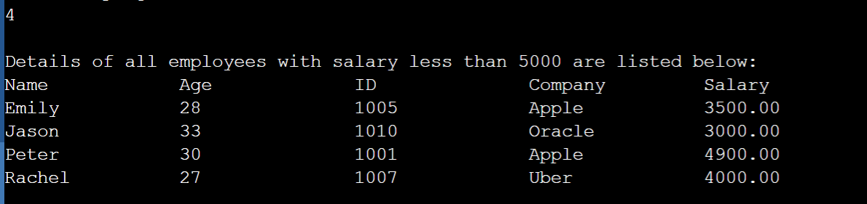

Question 3

Program description

Program is design to compile a set list of train schedule using array. The schedule is generate through random but a few constraint must be generated whilst the program run that is within the limit of the code such as ID/Schedule. The program also output the earliest and latest the schedule will run based on the output time.

Inputs and Outputs
The inputs and outputs for this program are described in Table 1.

Table 1. Data dictionary:
Data to be stored | Sample data | Type of data | C type | Input method | In /  Out | Variable name
ID | TrainID | Text:4 letters | char array | Random | printf | ID
Time | Schelude | Text: 2-20 characters | Array | Random | Printf | Schelude

3. Algorithm
Program steps:

- A schedule is generated from a random sran (Random Number Generator)
- The schedule is generated
- Printed to the screen.
- At the bottom – display lowest earliest time.
- Also display latest time when train arrive.
- Return unless initialize again.

Source code:
// Son Nguyen - 103234103//
// COS10007 Assignment 1//
// Question 3//
#include <stdio.h>
#include <stdlib.h>
#include <time.h>

//structure
struct Train{
int id;
time_t schedule;
struct Train* next;
};
//rng on train id
void constructTrainID(struct Train* arr, int size){
int i;
for (i = 0; i < size; i++){
arr[i].id = rand() % (200 - 100 + 1) + 100;
}
}
// rng on train schelude (time)
void constructTrainSchedule(struct Train* arr, int size){
int i;
for (i = 0; i < size; i++){
arr[i].schedule = time(NULL) + rand()%9999;
}
}
// displayList to print out train details
void displayTrainInfo(struct Train* arr, int size){
printf("Train information:\n");
printf("ID\t\t\t\tSchedule\n");
int i;
for (i = 0; i < size; i++){
printf("%d\t\t\t%s\n", arr[i].id, ctime(&arr[i].schedule));

}
}
// checking sche
void scheduleTrain(struct Train* arr, int size){
int i, j;
struct Train temp;
for (i = 0; i< size-1; i++)
{
for (j = 0; j < size - i - 1; j++)
{
if (arr[j].schedule < arr[j+1].schedule)
{
temp = arr[j];
arr[j] = arr[j+1];
arr[j+1] = temp;
}
}
}
}
// earliest arrival
void departEarliestTrain(struct Train* arr, int *size){
struct Train *head = NULL;
int i;
for (i = 0; i < *size; i++)
{
arr[i].next = head;
head = &arr[i];
}
// check if any train
if (head == NULL){
printf("No trains available to depart");
}
printf("Train %d has departed from the station at %s",head->id, ctime(&head->schedule));
head = head->next;
*size -= 1;
}
// latest arrival
void departLastTrain(struct Train* arr, int *size){
struct Train* head = &arr[0];
struct Train* cur = head;
int i;
for (i = 1; i < *size; i++)
{
cur->next = &arr[i];
cur = cur->next;
}
cur->next = NULL;
// check latest time departed
printf("Train %d has departed from the station. Its scheduled time is %s",head->id, ctime(&head->schedule));
head = head->next;
for (i = 0; i < *size-1; i++)
{
arr[i] = arr[i+1];
}
*size -= 1;
}
// menu to print
int main(){
srand(time(NULL));
int size = 10;
struct Train TrainArr[size];
constructTrainID(TrainArr, size);
constructTrainSchedule(TrainArr, size);
displayTrainInfo(TrainArr, size);
scheduleTrain(TrainArr, size);
departEarliestTrain(TrainArr, &size);
departLastTrain(TrainArr,&size);
return 0;
}

Screenshots showing working program (Show all possible outcome):
